# Forecasting Energy Demand: Harnessing IoT Data for Smart Grid Analytics

**Presented By:**

**Kotha Aswitha**

**A.V.P. Aravinda Rao**

**Ch. Yashwitha**

**G. Chandrakanth**

## **INTRODUCTION**

**SMART GRID:**

An electrical power distribution system that facilitates two-way communication between consumers and the utility supplier is known as a smart grid. Data centres, smart meters, controllers, and power/current sensors are examples of digital technologies that go into

Smart grid technology. There are superior and inferior smart grids. Large-scale, concentrated initiatives are underway in several nations to convert outdated electrical distribution networks into smart grids, but acceptance of these systems is difficult and takes years, if not decades.

**Importance of Smart Grids:**

Macroeconomic power consumption reduction depends critically on smart grids. Because adopting a smart grid is advantageous from a financial and environmental standpoint, many local governments and utility companies provide substantial incentives for participation. Energy production can be made more democratic by implementing smart grids, which will lower power system running costs, eliminate outage risks, and eliminate needless energy waste.

**Distribution boards with smart load control switches**:

Smart meters can give utility companies real-time data, but they don't automatically manage how electricity is distributed. Electric utilities employ distribution boards and smart load control switches, among other power management equipment, to improve distribution during peak consumption or to certain locations. By minimizing unnecessary distribution or automatically controlling loads that have surpassed their permitted time-of-use limitations, this technology saves a substantial amount of energy. To put it simply, the smart load control switches can maximize overall system distribution and consumption efficiency by intelligently turning power distribution on and off at the point of usage.

**Traditional Electricity Grid vs Smart Grid**

|  |  |  |
| --- | --- | --- |
| **S.no.** | **Traditional Electricity Grid** | **Smart Grid** |
| 1. | Centralised Power generation | Distributed power generation |
| 2. | Manual monitoring | Realtime monitoring |
| 3. | There is a higher risk of blackouts and failures | Low risk due to adaptive and islanding properties |
| 4. | Absence of energy storage | Good scope for energy storage |
| 5. | Low sensor deployment | High Sensor deployment |
| 6. | Rapid grid topology | Network grid topology |
| 7. | Less environment friendly | More environment friendly |
| 8. | Response time will be slow | Response time will be quick |
| 9. | Electromechanical system | Digital Smart grid system |
| 10. | One-way communication | Two-way communication |

Over the years, centralized electricity generation from power plants has gradually transitioned toward a distributed energy resource for adapting to a dynamic energy industry and elevating the energy experience for consumers.

The need to update the traditional electricity grid to a smart grid stemmed from several reasons, such as:

* Availability of more renewable energy and connected technologies
* Deregulation of the energy market
* Electricity production changes
* Growth of electric vehicles
* Metering evolution
* Need for remote grid management
* Renewable energy directives
* Rise of microgeneration and isolated microgrids
* The advent of the prosumer (one who produces, consumes, shares, and sells energy)

**Advantages of Smart Grid:**

* Reduce the demand for electricity during peak hours to lessen grid stress.
* Give customers more options when it comes to utilizing account plans and "customized" tariffs.
* Increase network dependability by making efficient use of grid capacity.
* Give consumers visual feedback on patterns of consumption or power usage to assist them save money on electricity.
* Early detection of electrical network flaws and fraud is necessary to prevent incidents.
* Give utilities the ability to control energy consumption and save operational expenses.
* Boost the security of grid employees and vendors.
* Launch a prompt demand response (DR) to ease the burden on electricity providers.
* Stop theft of electricity by interfering with the meters.
* Acknowledge that networked assets require maintenance.
* Cut back on emissions of pollutants like CO2, NO2, and SO2.

### **Objectives:**

* To create demand response programs that reward customers for modifying their energy use in response to real-time grid circumstances by Reducing peak demand and improving grid stability by using IoT data insights.
* To Enhance grid resilience by leveraging IoT data for predictive maintenance, early fault detection, and proactive grid management, thereby minimizing downtime and improving reliability.
* To Develop anomaly detection algorithms to identify irregularities or abnormalities in energy consumption patterns, which could indicate faults, tampering, or inefficiencies in the grid.
* To Develop algorithms to accurately forecast energy demand at various temporal and spatial scales, considering factors like weather patterns, time of day, day of the week, and seasonality.

# MOTIVATION

* The pressing need for an energy infrastructure that is more sustainable, dependable, and efficient is the driving force behind energy demand forecasting and the use of IoT data for smart grid analytics.
* The integration of renewable energy sources, aging infrastructure, rising demand, and environmental concerns are just a few of the difficulties faced by traditional energy systems. It becomes essential in this situation to use IoT technology to collect real-time data and predictive analytics to estimate energy needs.
* First and foremost, the optimization of energy production, distribution, and consumption depends on precise demand prediction. Utilities can prevent shortages or overloads, maximize resource allocation, and save costs by accurately anticipating energy demand and modifying their operations. Both customers and suppliers gain from increased energy supply efficiency and dependability as a result.
* Second, a thorough grasp of the health and performance of the grid in real time is made possible by the integration of IoT data. IoT sensors are positioned across the grid infrastructure to gather data on environmental factors, equipment health, energy usage, and grid stability.
* By analysing this data, anomalies or problems can be found early on, allowing for preventive maintenance and a decrease in downtime. It also strengthens the grid's resistance to unanticipated occurrences like severe weather or cyberattacks.
* Utilizing IoT data also helps the energy ecosystem shift to one that is more sustainable. Utilities may cut waste, eliminate transmission losses, and incorporate renewable energy sources more successfully by optimizing energy distribution and load balancing. This helps to lessen the total impact of energy generation and distribution on the environment and carbon emissions.

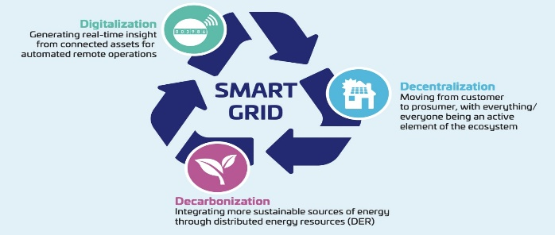

Figure-1: SMART GRID

# Methodology

The following crucial elements are usually included in the technique for data analysis used to estimate energy consumption and use IoT data for smart grid analytics:

* **Data Collection and Integration**: Collect information from a range of sources, such as weather stations, grid sensors, energy meters, Internet of Things devices, and other pertinent sources. Make sure that diverse data kinds are combined into a single dataset so that it can be analysed.
* **Data Pre-processing**: To deal with missing numbers, outliers, and inconsistencies, clean up the data. To guarantee data quality and consistency, perform scaling, transformation, and normalization as necessary.
* **Feature Engineering**: Determine the pertinent elements or variables—such as the season, the day of the week, the weather, and past patterns of energy consumption—that affect the demand for energy. Develop fresh functionality or extract valuable data to improve the prediction capability of the model.
* **Model Selection**: Depending on the forecasting horizon and the type of data, select the right forecasting models. Common models include deep learning models like recurrent neural networks (RNNs) or long short-term memory (LSTM) networks, machine learning algorithms like random forests, gradient boosting machines, exponential smoothing techniques, and time series analysis techniques like ARIMA (Auto Regressive Integrated Moving Average) and SARIMA (Seasonal ARIMA).
* **Training Models**: Divide the dataset into sets for validation and training. Use cross-validation approaches to optimize model performance and fine-tune hyperparameters while you train the chosen models on the training set. To evaluate the models' accuracy and generalizability, validate them using the validation set.
* **Model Evaluation**: Depending on the particular needs and characteristics of the problem, assess the performance of the trained models using appropriate metrics like mean absolute error (MAE), mean square error (MSE), root mean square error (RMSE), or others.
* **Model Interpretation**: To understand the variables influencing energy demand and prediction accuracy, analyse the output of the trained models. Evaluate the model's ability to capture temporal patterns, seasonality, and trends in the data, as well as the significance of the input features.
* **Implementation and Observation**: Install the learned models in real-time forecasting and decision-making contexts. Install monitoring systems to keep tabs on model performance, spot anomalies or drifts, and help with model recalibration or retraining as necessary to keep accuracy and dependability over time.
* Iterate and improve the data analysis process continuously in response to feedback, fresh information, and new developments in technology. To improve the efficacy and efficiency of subsequent analysis, take into account the lessons discovered from previous experiences.

**Code:**

import streamlit as st

import pandas as pd

import numpy as np

from sklearn.ensemble import RandomForestRegressor, GradientBoostingRegressor

from sklearn.linear_model import LinearRegression

import matplotlib.pyplot as plt

@st.cache

def load_data(file_path):

data = pd.read_csv(file_path)

return data

def train_model(algorithm, X_train, y_train):

if algorithm == 'Random Forest':

model = RandomForestRegressor()

elif algorithm == 'Gradient Boosting':

model = GradientBoostingRegressor()

elif algorithm == 'Linear Regression':

model = LinearRegression()

else:

raise ValueError("Invalid algorithm selected")

model.fit(X_train, y_train)

return model

def predict(model, X_test):

return model.predict(X_test)

def main():

st.title('Energy Demand Forecasting with IoT Data')

algorithm = st.sidebar.selectbox('Select Algorithm', ['Random Forest', 'Gradient Boosting', 'Linear Regression'])

file_path = st.sidebar.file_uploader('Upload IoT Data', type=['csv'])

if file_path:

data = load_data(file_path)

data = preprocess_data(data)

st.subheader('Loaded Data')

st.write(data)

X = data.drop(columns=['serial', 'Time_stamp','kVAR'])

y = data['kVAR']

model = train_model(algorithm, X, y)

st.subheader('Predict on Test Dataset')

serial = st.number_input('Serial', value=0)

kWh = st.number_input('kWh', value=0.000 )

kW = st.number_input('kW', value=0.000)

kVARh = st.number_input('kVARh', value=0.000)

if st.button('Predict'):

test_data = pd.DataFrame({'serial': [serial], 'kWh': [kWh], 'kW': [kW], 'kVARh':[kVARh]})

test_X = test_data.drop(columns=['serial’])

prediction = predict(model, test_X)

st.subheader('Prediction’)

st.write(prediction)

**Results:**

**Output1: Random Forest**

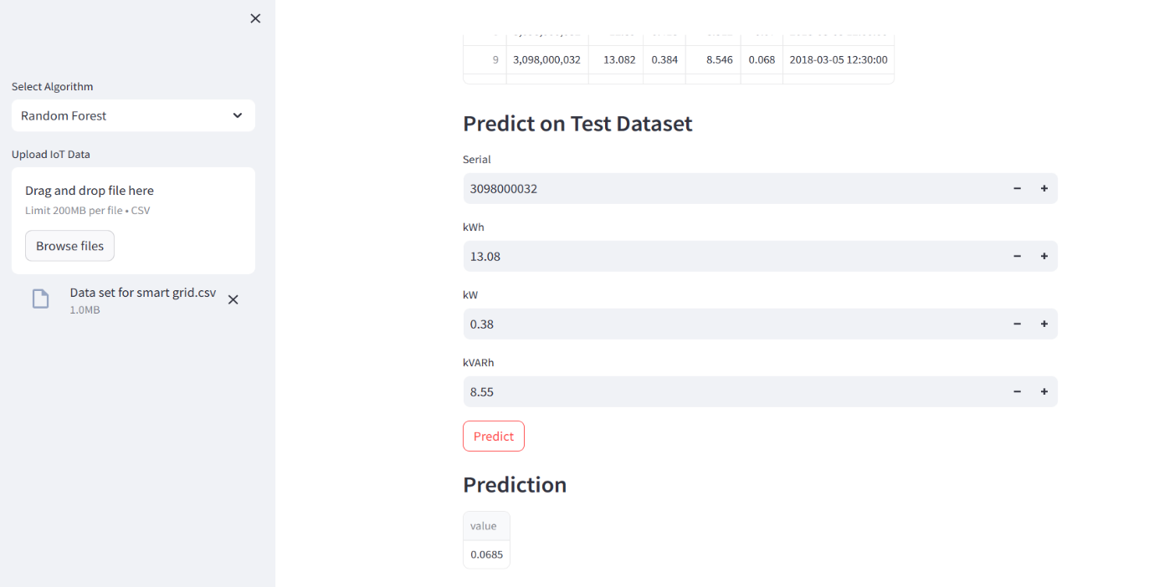

**Output 2: Gradient Boosting**

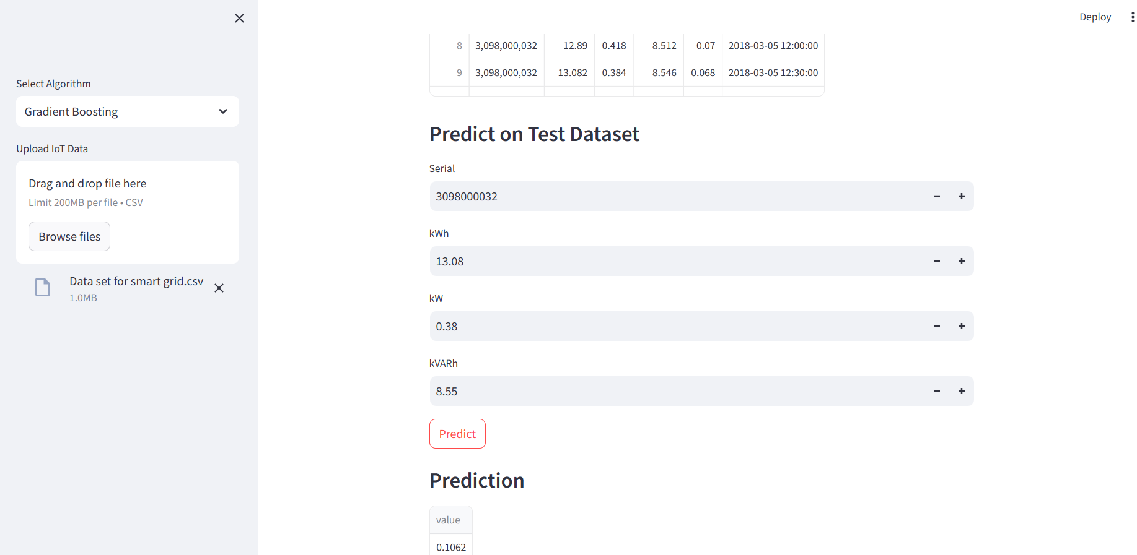

**Output 3: Linear Regression**

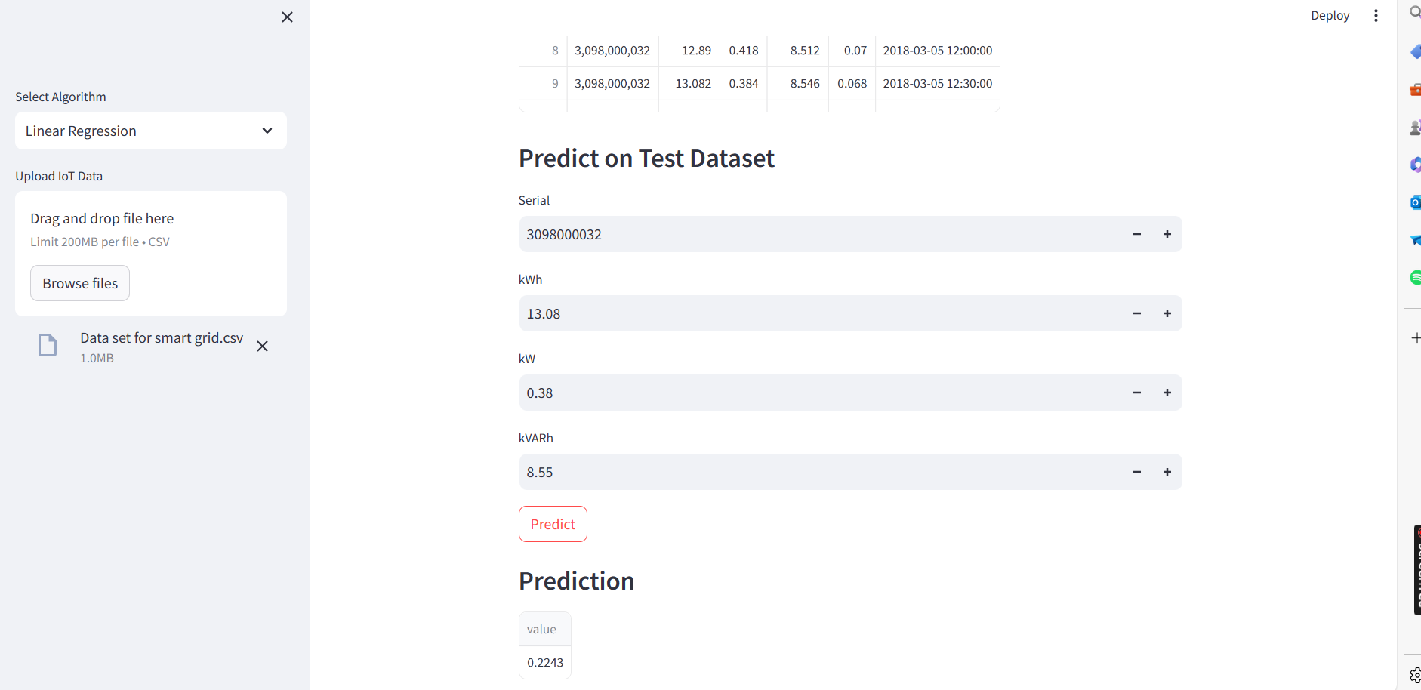

**Conclusions:**

* With the help of IoT-enabled data analytics , tools can improve grid efficiency and operations by gaining helpful knowledge about energy demand forecasting.
* Accurate demand forecasting supports the integration of renewable energy sources, contributing to a more sustainable energy infrastructure.
* Engaging consumers through personalized insights encourages energy-saving behaviors and promotes active participation in demand-side management.
* Predictive maintenance strategies improve grid reliability and reduce maintenance costs by anticipating equipment failures and optimizing maintenance schedules.
* Leveraging IoT data analytics for smart grid applications not only meets regulatory requirements but also fosters innovation and drives the transition towards a more resilient and sustainable energy future.

**Future Scope:**

* Enhanced forecasting will facilitate better integration of renewable energies, optimizing their use based on accurate demand predictions.
* Further automation of grid operations using real-time IoT data will optimize energy distribution and improve system responsiveness.